BASIC PYTHON
INPUT() AND PRINT() FUNCTIONS
input():
input() is a predefined function that helps to get a customized value from the user during execution time in string format.
print():
print() is a predefined function that helps to display the output on the screen.
Example:
var = input("Enter a value: ")
print(var)
print(type(var))
print("===============================")
n1 = int(input("Enter the first number: "))
n2 = int(input("Enter the second number: "))
sumval = n1 + n2
print("Sum value is:", sumval)
print(type(sumval))
print("===============================")
TASK:
Write programs for Subtraction, Division, and Multiplication.
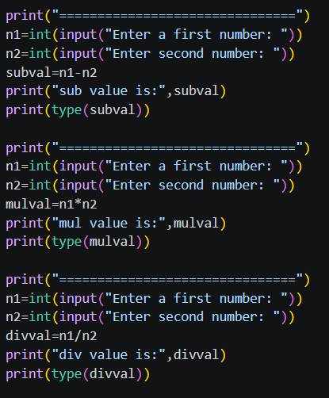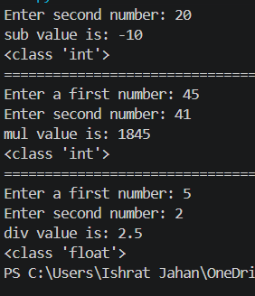
--------------------------------------------------------------------------------------------------------------------------------
OPERATORS
An operator is a special symbol or keyword that is used to perform an operation on values.
Example:
7 + 34
Operands: 7, 34
Operator: +
Operation: Addition
Operands: Operands are the values that are involved in an operation.
Operator: An operator is a special symbol or keyword that has built-in functionality, based on which an operation is performed on values.
Operation: An operation is an action that is performed on values based on the operator used.
TYPES OF OPERATORS
There are 7 types of operators:
- Arithmetic Operators
- Comparison / Relational Operators
- Logical Operators
- Bitwise Operators
- Assignment Operators
- Membership Operators
- Identity Operators

- Arithmetic Operators:
- To perform mathematical operations on numbers
- I/P: numbers O/P: number
- +, -, *, **(exponentian), //, /, %

+:
  - When used with minumum of 2 number it perform addition
  - When used with a single number it represemt +ve number
Ex:
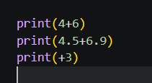

-: When used with minunum of 2 number it perform subratiion
When used with a single number it represemt -ve number
Ex:
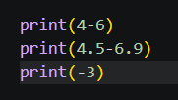

*: When used with minunum of 2 number it perform multiplication
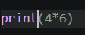

**: it returns the exponent val of the given base and power
Base ** power

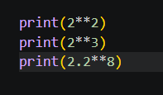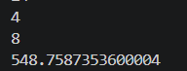

//: Floor division /: float division %: modulo
Ex:
Floor division (non-decimal quotient)
Remainder (internal perform the floor division)
Return decimal quotient
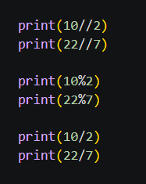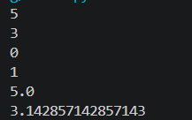

- Comparison / Relational Operators
- It is used to compare the minium of 2 value
- It returns Boolean value (True or false)
- Any values can be taken as input
- >, <, ==, >=, <=, !=
True, false and none are special kind of keyword that hold values (first letter is upper case)
True----1
False--0
None---nothing
Ex:
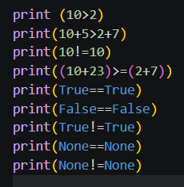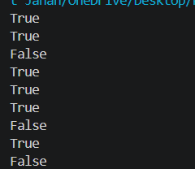

- Logical Operators
- It is used to combine and check multiple Boolean condition
- I/P: Boolean condition, anything which represent the
  - Boolean condition
    - Direct bool_val or anything that represent Boolean value
    - An expression that returne Boolean value or anything that represent bool value
    - Any var that hold bool val anything that represents bool val

- Boolean value or anything that represents bool values
- Types: and, or, not
NOTE: Any non-zero values are considered to be true
Any empty objects, “”, 0, (), {}, [], False, None are considered to be false

AND:
Cond 1 | Cond 2 | O/P
T | T | T
T | F | F
F | - | F
- If the initial condition is False it will not check forward

OR:
Cond 1 | Cond 2 | O/P
T | T | T
T | F | T
F | - | F
- If the initial condition is true the it wont check for the next condition

NOT:
- it accepts only one single operand to perform the operation
- it strictly returns true or false
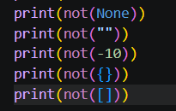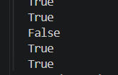
- Bitwise Operators
Types:
  - Bitwise and &
  - Bitwise or |
  - Bitwise not/ negation/ complimentt ~
  - Bitwise left shift <<
  - Right shift >>
  - Bitwise unsigned left shift <<<

- Assignment op:
- Commonly it doesn’t return any value
- It stores /copies value mentioned on RHS to named memory location on the LHS
  - Syntax:
Var_name1=val [initialization]
Var_name2=var_name1[copying]
Var_name2=val [re-initialization]
VARIABLES
--------------------------------------------------------------------------------------------------------------------------------
- It is a named memory location that holds single valued data
- It is name that is given to a container that holds data
- If we try to store the same value into different variables, then internally all the variable will be pointing to the same shared memory location
NOTE: id () it is a pre – defined function that displays the ID value of the provided data
It is an integer value that is generated by PVM during execution time basedok the value stored or memory allocated.
- If the multiple value is tried to be stored into the same variable one after the other then internally different memories will get allocated for each initialization
- It is compulsory to initialize a variable before utilization

VARITIES OF VERIABLES [Compound statement]
- Arthmatic + Assignment: +=, -=, **=, //=, /=, %=
- Bitwise + Assignment: &=, |=, ^=, <<=, >>=, <<<=
Rules:
- Whenever the oprand used on RHS for operation and LHS for updation is the same
- It is compulsory to use initialized vars
- Apaer from the initialized vars , even direct constants can be used
- Minimum of 2 oprands are required to performed the operation
- The operand which is used on RHS for operation and LHS for updation, should be present on the LHSof the operation
Eg:
a= a + b valid
a= b + a not valid
Note: ~=is not included under compound statemnent as it required only a single oprand to perform the operation

Compound statememt
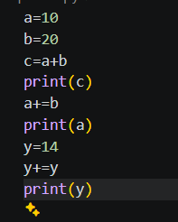
The value for which you want to assign must be present in the start

Identity op: [is, is not]
- It compares the ID’s of the given values
- It returns only Boolean values

Membership operatior:
- It checks wether the specific elements is present in a group od elements or iterable object or not
- It returns only Boolean value
iterable object : object that hold hold multiple individual elements into the same shared memory location
eg: list, string, set, tuples, dictionary
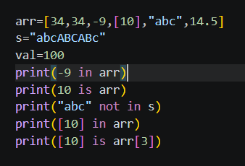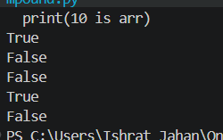

Contro; Folw statement
- The statement that controls the execution flow of the program
- Type:
  - Conditional statement
a. simple if
b. if-else
c. elif ladder/if-else-if ladder
d. shorthand
2. Lopping statement
a. for loop
1. for with range()
i. incre
ii. decre
2. for without range()
b. while loop
3. Jumping statements
. break
. continue
. return
For loop:
range():
  - It is pre- defined function that help to execute the defined sequence values internally
Syn: range(start, stop/end,step)
  - Start ,stop, step om;y be integers
Startfrom where the sequence should begin default start is 0
End/stop It is compulsory to be passed
Defined TILL where the sequence should get execurrted
Step the difference between the current element and the next element default start is +1
a. for with range():
for var_name in range (start,end,step):
#logic
#remaining statements
1. incrememnt for loop:
For var_name in range (start, (actual end+1), positive_step):
#logic
# remaining

Weite a program to display the natural number from beginning with a difference of three up to n where n is also included
Rules:
  - Pass a positive step
  - Start< end value
  - If the actual end val also need to be included then (actual end + 1)
2. decrement for loop:
For var_name in range (start, (actual end-1), negative_step):
#logic
# remaining
Rules:
  - Pass a negative step
  - Start> end value
  - If the actual end val also need to be included then (actual end - 1)

Display the natural number starting from n to 1 in the decremention order eith a difference of 4

b. for without range
- A for loop without range() is used to iterate directly over the elements of a sequence such as a list, tuple, string, or set.
- Syntax:
for variable_name in iterable_obj/group_of_elements :
statements

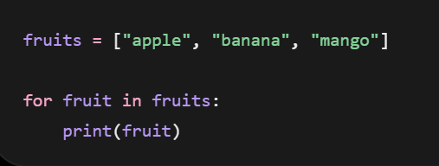
Rules:
  - No single value data
  - The cursor move in the forward direct int ‘
  - It directly fetches each individuak value
  - Even emply iterablke object work
  - Group of element can be passed by segrigating them using comma
Note:
  - For with range when used on iterable object like array/string, it represents the index
  - For without range when used on iterable object like array/string, it represent values
  - 